Winter 2020 Weekly Class Schedule

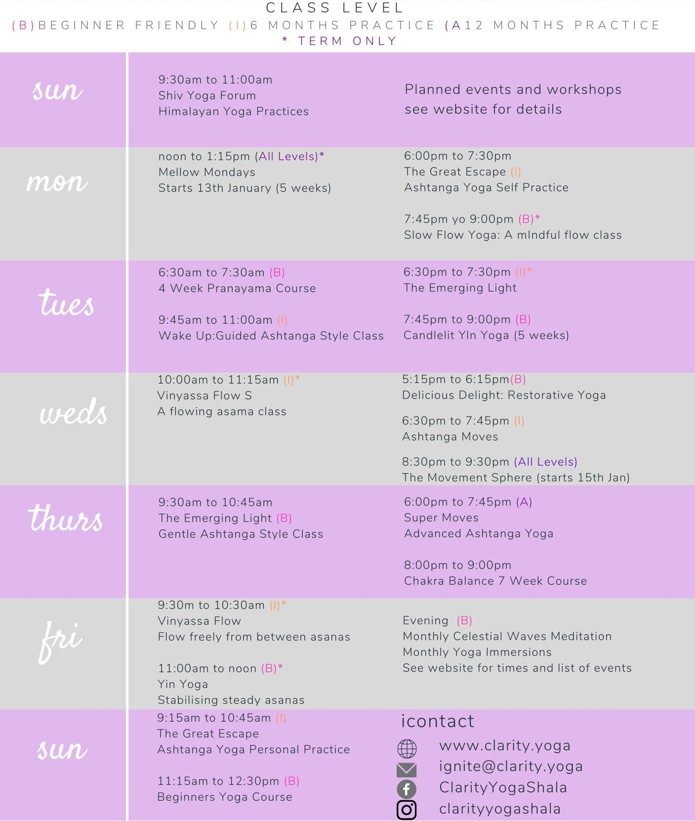

*Last updated 3 January 2020*

May the jewel

­­in the lotus

shine forth this light

of love

and compassion

to unite

all existences

as one

CLARITY YOGA SHALA

65 Hatfield Road

St Albans

AL1 4JE

ignite@clarity.yoga

www.clarity.yoga

+44 (0) 796 8823166

Clarity Yoga

Shala

